Victorian National Parks Association Inc.
Level 3, 60 Leicester Street Carlton Vic 3053,
Tel: (03) 9347 5188, Fax: (03) 9347 5199
Email: vnpa@vnpa.org.au website: www.vnpa.org.au
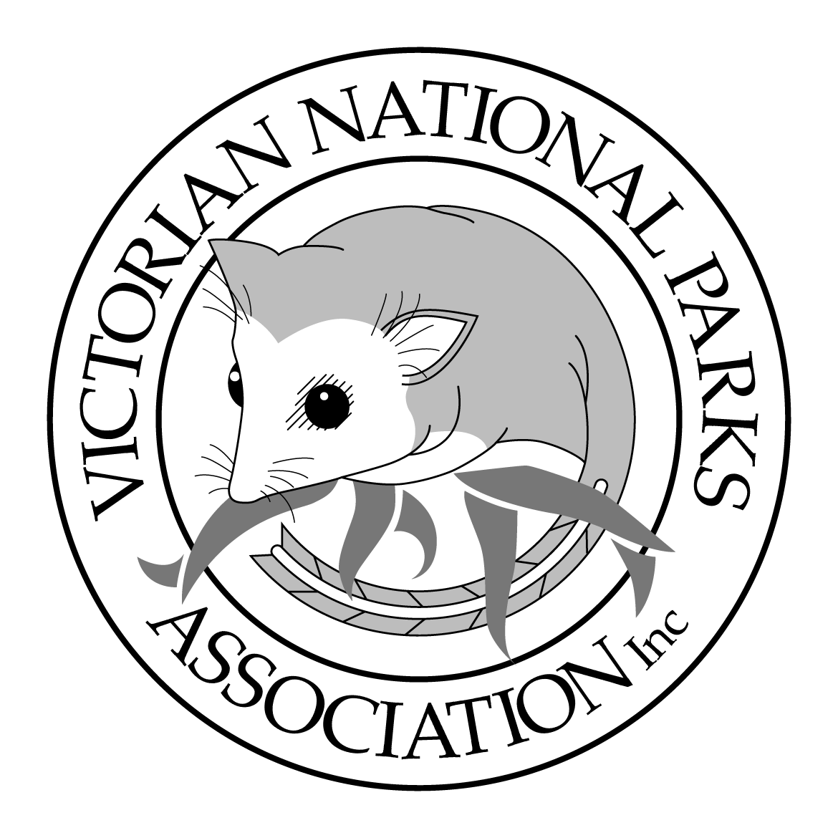

21 January 2004

Open letter to:
The Hon. Ian Campbell MP,
Minister for Environment and Heritage
Parliament House
Canberra
ACT 2600

Re: Proposed National Heritage emergency listing of alpine grazing licences

Dear Minister,
I am writing to alert you to a range of issues surrounding the proposed National Heritage emergency listing of alpine grazing licences, and to inform you of nationally significant heritage values at risk from cattle grazing in Victoria’s Alpine National Park.
We do not believe that the recent application by the Mountain Cattlemen’s Association for emergency listing of “alpine grazing leases in the high country of the Victorian Alps” can succeed under the EPBC Act, and draw your attention to issues relating to that application.
(See attachments A and B to this letter.)
The Victorian National Parks Association has long been drawing attention to the need for better conservation management of Victoria’s alpine region. In 1974 we published a landmark book “The Alps at the Crossroads” outlining the remarkable cultural and environmental heritage of the Alps, and the need to protect those values.
In the same work, the VNPA called for formation of an Alpine National Park in Victoria, and also recommended “that cattle be phased out of the high country in the long term”. This call was neither intended to be, nor seen to be, an attack on cattlemen, but was a clear statement on the environmental and economic unsustainability of cattle grazing in the High Country.
Cattle had already been removed from Kosciuszko National Park in the 1960s - largely for water quality reasons - and from some parts of the Victorian high country, such as Mount Buffalo, in the mid 1950s.
Thirty years on, the ecological impact of cattle grazing in the Victorian Alps is one of the most thoroughly and systematically studied natural resource management issues in Australia. That cattle are damaging the Alps is a well-established fact.
In short, licensed cattle grazing in Victoria’s Alpine National Park is an anomaly that makes effective management of the park impossible and increasingly expensive, and that has for some time now compromised the pursuit of World Heritage nomination for the alpine region.
Essentially, cattle in the park:
- trample, drain and eventually destroy streamsides, ancient peat beds and other alpine wetlands, compromising the headwaters of many major rivers in Victoria,
- threaten the survival of a number of unique native plant and animal species in the region,
- cause considerable changes to vegetation communities across the High Plains (primarily through a great decrease in alpine wildflowers, and the spread of flammable shrubs),
- help the spread of many environmental weeds.
In addition, the cost to the Victorian Government of managing grazing in the park (over $500,000 a year and growing) is in no way recovered by income from licence fees (around $30,000 a year).
But an equitable solution to this problem is within our reach.
We believe it is possible to transform this unfortunate situation, by supporting both the diverse natural and cultural heritage (including the rich history of Indigenous occupation, recreation, tourism and scientific research) of the region, and helping to build a truly sustainable economy in north-eastern Victoria.
This can be done by:
- removing licensed grazing of domestic stock from the Alpine National Park, allowing much needed rehabilitation of grazed areas, and freeing-up park staff and park resources to deal with other pressing park management issues,
- giving transitional assistance to affected farmers, so cattle can be relocated to less sensitive areas outside the park, or farmers can readjust their farming practices;
- increasing employment of skilled local horsemen and women in feral horse management, both on and off-park,
- giving assistance to promotion of, and infrastructure development for, sustainable tourism along the Great Alpine Road. Such an initiative would help set the region on a far more promising economic path than continuing to prop up an unsustainable farming practice.
It should be noted that most bush grazing licences in the area are already outside the boundaries of the national park. These would not be affected by any decision to shift grazing from the Alpine National Park to less environmentally sensitive areas. Thus the majority of mountain cattlemen would not be directly affected.
It is important to remember that farmers throughout Victoria now routinely fence cattle away from streams, wetlands and sensitive native vegetation on their properties. And yet, in the Alpine National Park – public conservation estate - cows are still allowed to trample creeks, streambanks and other wetlands throughout the licence areas. This practice is contrary to the principles of modern Landcare farming.
The current Memorandum of Understanding in relation to the Co-operative management of the Australian Alps National Parks, signed by the Minister David Kemp and the Environment Ministers of Victoria, NSW and the ACT in 2003, calls for:
“…complementary policies and management practices throughout the Australian Alps National Parks.”
As matters stand, ongoing cattle grazing in Victoria’s Alpine National Park is the single greatest anomaly and obstacle to consistent and sustainable management of those parks.
We note also that, in your maiden speech to the Senate, you gave notice of your commitment to environmentally sustainable development. We are particularly heartened by your comment that:
Past generations of Australians have been responsible for visiting some major environmental disasters upon this nation, but I do not think it is fair, relevant or helpful for us to place all the blame on our forefathers. What is relevant is that our generation assume responsibility for rectifying those past mistakes. What we must also do is ensure that our natural environment-and our knowledge of how to manage it-is passed on to the future generations in a far better condition. This is a goal I will work towards as a senator and a goal I will encourage my generation to share.
We share these sentiments, and would be happy to discuss this issue with you at any time.

Yours sincerely
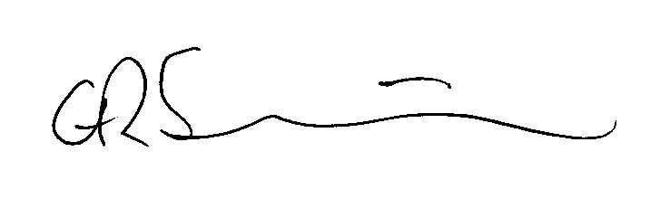
Charlie Sherwin
Director

Note: there are two attachments to this letter, for your information.
Attachment A: A summary of listings, studies and reports on the effects of cattle grazing in Victoria’s Alpine National Park.
Attachment B: A short response to the MCAV’s request for emergency listing of grazing licence areas in the Alpine National Park.

Attachment A: A summary of listings, studies and reports on the effects of cattle grazing in Victoria’s Alpine National Park.

While Victoria’s National Parks Act 1975 (NP Act) currently allows the licensing of cattle grazing in the Alpine National Park (ANP), there is no evidence that the management agencies (Parks Victoria and DSE) can manage grazing in a manner consistent with responsible conservation management principles, or indeed with the principle object of the Act (s. 4):
‘the preservation and protection of the natural environment.’
We believe that fundamental provision of the NP Act, together with the internationally accepted World Conservation Union (IUCN) criteria for national park management, mean any attempt towards responsible management of grazing within the park has always been impossible.
We note that the IUCN’s protected area Category 2, National Park, is identified as a:

‘Natural area of land and/or sea, designated to:
- Protect the ecological integrity of one or more ecosystems for present and future generations;
- Exclude exploitation or occupation inimical to the purposes of designation of the area and;
- Provide a foundation for spiritual, educational, recreational and visitor opportunities, all of which must be environmentally and culturally compatible.’
There is abundant scientific evidence that cattle grazing is ‘inimical to the purposes of designation’ of the ANP, indeed there has been evidence for many years.
We are quite satisfied with the conclusions of two impeccable reports to the Victorian Government agencies responsible for management of the Alpine National Park, assessing the accumulated scientific evidence on grazing.
These reports are:
1/ Williams, R. J. Papst, W. A. and Wahren, C-H (1997) The Impact of Cattle Grazing on Alpine and Sub-alpine Plant Communities of the Bogong High Plains. Report to the Dept of Natural Resources and Environment, Victoria.
It found (p.40) that:
“Continued grazing is an undoubted cost to national park values and, indeed, compromises national park management. Any claims made with respect to the benefits of grazing to alpine ecosystems are not supported by scientific evidence.”
2/ Groves, R. H. (1998) Grazing in the Victorian High Country Report to Parks Victoria.
This report found that (p. 6):
“There is no scientific reason why grazing by non-native animals should not have been excluded from the Victorian high country as early as 40 years ago. That grazing under licence has persisted in Victoria to the present is an indictment of Victorian land management authorities, including Parks Victoria and its predecessors, who have failed to take into account the scientific evidence available and give it its due in the politics of making decisions on land management.”
There is no need for further scientific review of this issue. The available evidence is more than enough to justify removal of grazing from the park. But we also note a number of listings under Victoria’s Flora and Fauna Guarantee Act 1988 (FFG Act) which clearly implicate grazing in the park as a threat to the health, indeed survival, of natural systems.
In particular, Soil Erosion and Vegetation Damage and Disturbance in the Alpine Regions of Victoria Caused by Cattle Grazing is listed as a Potentially Threatening Process (Nomination no. 211).
And cattle grazing is clearly and significantly implicated in the listings and action statements of two additional FFG Threatening Processes: the Increase in Sediment Input to Rivers and Streams due to Human Activities and Degradation of Native Riparian Vegetation along Victorian Rivers and Streams.
That the recommendations in the Action Statements of these listings are effectively ignored, within a National Park that ostensibly ‘protects’ the headwaters of most of the significant river systems in Eastern Victoria, beggars belief. Essentially, management of stock grazing within one of Australia’s most significant national parks doesn’t even follow current farming practices (eg exclusion of stock from waterways) almost universally practised on private farmland throughout the State.

Victoria’s Alpine National Park has many species and communities listed as threatened under both State and Federal legislation.
Importantly, the predicament of these listed threatened species and communities should be seen against the background of an additional listing of a key threatening process under the Federal EPBC Act: “Loss of terrestrial climatic habitat caused by anthropomorphic emissions of greenhouse gases”. This listing specifically includes alpine habitats in that threat. This is not surprising, given that high altitude species have little or no opportunity to migrate to avoid habitat changes caused by rising temperatures.
In this context, any additional threats (such as that posed by cattle grazing) should be avoided at any cost.

Within Victoria’s Alpine National Park, and within grazing licence areas, there are a number of alpine and sub-alpine communities and individual species individually listed as threatened by the grazing of cattle. The following list is not comprehensive:
Alpine Bog Community
Alpine bogs, sometimes known as peat bogs or mossbeds, have been listed as a threatened community under Victoria’s FFG Act since 1991. Physical disturbance by cattle trampling, leading to the dissection and subsequent eutrophication of the bogs, is one of the main listed threats.
(In addition, “Montane Peatlands and Swamps” are listed as an endangered ecological community under the NSW Threatened Species Conservation Act, and there is a current nomination in process for the listing of “Alpine Bogs” under the EPBC Act.)

Fen (Bog Pool) Community
This community, also listed under Victoria’s FFG Act since 1991, is threatened by physical disturbance caused primarily by cattle. Fens are particularly vulnerable to trampling and draining by cattle during drought years.

Alpine Snowpatch Community
The snowpatch community listed under Victoria’s FFG Act is a “Short Turf” or “Diuturnal Snowpatch” characteristic of the southern Bogong High Plains, and is quite different to the snowpatches of higher areas north of Falls Creek, or those in Kosciuszko National Park. That is, the great majority of these snowpatch communities are found within cattle grazing licence areas of the Bogong High Plains in Victoria’s Alpine National Park. The FFG listing states that “the main threat to the community is physical disturbance, caused primarily by cattle grazing and trampling”.

Caltha introloba Herbland Community
This community, an “open herbfield on flat, rocky outwashes of snowpatch communities” has been listed under Victoria’s FFG Act since 1992. It has a very restricted distribution, and its only occurrence in Victoria is on the Bogong High Plains and very much within current cattle grazing licence areas. This community is very vulnerable to trampling by cattle, and very few examples remain now in Victoria.
Poa helmsii, Carex appressa Community
Another community of particular interest is the Poa helmsii, Carex appressa community in the basalt grasslands in the vicinity of Mount Jim and Mount Fainter. This distinct community is only found in Victoria, and entirely within grazing licence areas in the Alpine National Park. It is vulnerable to grazing by cattle. *

A number of plant species currently affected by cattle grazing in The Alpine National Park are listed under the EPBC Act. Most notable are:
Euphrasia eichleri (Bogong Eyebright), a Victorian endemic found on the Bogong High Plains and the Dargo High Plains. It is highly vulnerable to grazing, and is now limited on the Bogong High plains almost entirely to areas from which grazing has been removed (eg the Pretty Valley exclusion plot, and Mount Nelse). Its recovery and distribution would most probably benefit greatly from an end to grazing in the park.
Kelleria laxa (Drapetes), a Victorian endemic limited to a very small, vulnerable population on Mount Jim, within a grazing licence area.
Thesium australe (Austral Toad-flax), a grassland species found at Limestone Creek, Rocky Plain and Emu Plain, within grazing licence areas.

Three reptiles listed under Victoria’s FFG Act are very vulnerable to cattle grazing. They are:
Eulamprus kosciuskoi (Alpine Water Skink) ( Nom. 222; Action Statement 114).
Pseudemoia cryodroma Alpine Bog Skink (Nom. 390),
Cyclodomorphus praealtus Alpine She-oak Skink (Nom. 393; Action Statement 113).
Another reptile, Egernia guthega, is not currently listed under the EPBC Act or the FFG Act, but appears on Victoria’s Threatened Species list as critically endangered. It is found only on the Bogong High Plains, in grassland areas adjacent to rocky outcrops, and is vulnerable to cattle grazing.
A number of other alpine and sub-alpine species and communities affected by cattle grazing are separately listed as threatened under the FFG Act, notably the:
Mountain Daisy Brachyscombe tenuiscapa (Nom. 169);
Silky Daisy Celmisia sericophylla (Nom. 220);
Dwarf Sedge Carex paupera (Nom. 176);
Rock Tussock Grass Poa saxicola (Nom. 177);
Silver Caraway Oreomyrrhis argentia (Nom. 178);
Mountain Cress Drabastrum alpestre (Nom. 174);
Fairy Bluebell Wahlenbergia densifolia (Nom. 175;
Rough Eyebright Euphrasia scabra (Nom. 153);
Snow Pratia Pratia gelida (Nom. 467);
Bent Grass Deyeuxia affinis (Prelim. Rec. 655);
Carpet Willow Herb Epilobium willisii (Nom. 171).
(Note: the Carpet Willow Herb, known only from grazing licence areas on the Dargo High Plains in Victoria, has not been sited for many years and may already be extinct.)
In addition a further 30 (non-FFG listed) plants, all within grazing licence areas of the Alpine National Park and likely to be affected by grazing, are listed as vulnerable or threatened in Victoria, including:
Aciphylla glacialis Snow Aciphyll
Barbarea grayi Native Wintercress
Cardamine astoniae Spreading Bittercress
Cardamine franklinensis Franklin Bittercress
Carex Archeri Archer’s Sedge
Carex echinata Star Sedge
Carex hypandra Alpine Fern-sedge
Coprosma pumilla Dwarf Coprosma
Craspedia alba White Bully-buttons
Craspedia lamicola Allied Bent-grass
Diurus ochroma Pale Golden Moths
Erigiron conyzoides Daisy Fleabane
Euphrasia collina ssp diversicolor Purple Eyebright
Euphrasia eichleri Bogong Eyebright
Juncus antarcticus Cushion rush
Luzula atrata Slender woodrush
Oreomyrrhis brevipes Branched Caraway
Oreomyrrhis pulvinifica Cushion Caraway
Pelargonium helmsii Mountain Stork’s-bill
Poa labillardierei var acris Sharp Mountain Tussock-grass
Poa petrophila Rock Tussock-grass
Prasophyllum rogersii Marsh Leek-orchid
Prasophyllum sp aff brevilabre (SW Vic) Western Short-tip Leek-orchid
Ranunculus mueleri var muelleri Felted Buttercup
Rytidosperma australe Southern Sheep-grass
Senecio georgianus Grey Groundsel (extinct already?)
Uncinia sulcata Small Hook-sedge
Utricularia monanthos Tasmanian Bladderwort

A host of others are listed as rare.
The existence of such a suite of listings in relation to clearly identified threatening processes in such a significant protected area presents a serious management challenge.

Important note on natural values
It should be noted that, though many of the plant communities threatened or compromised by grazing in Victoria’s Alpine National Park are similar to communities in Kosciuszko National Park across the border, there are significant differences.
Therefore grazing in Victoria cannot be justified on the grounds that these communities are adequately protected in Kosciuszko National Park. *

Heritage values.
The National Heritage significance of the natural values of Australian Alps is well established in a number of studies, and the World Heritage status of the Alpine region has been well documented in at least two studies. Significantly both of these list grazing by domestic stock as an obstacle to the progress of World Heritage nomination for the area.
In Australian Alps World Heritage Nomination Proposal by Geoff Mosley (1988), it states (p. 99):
“In Victoria the continuation of grazing, even though more carefully controlled, is hindering the recovery and is incompatible with World heritage status… World heritage nomination will necessitate a review of the continued existence of of the (grazing) licences and the making of policy consistent with Kosciuszko and Namadgi National Parks.”
And The International Significance of the Natural Values of the Australian Alps by J.B. Kirkpatrick (1994), a report commissioned by the Australian Alps Liaison C’ttee, confirms that judgment (p. 6):
“The chances for a successful nomination for World heritage would be improved by further commitment to the elimination of current threatening processes, and the mitigation of the effects of past disturbances. A commitment to the removal of stock grazing would be important.”

*From “Treeless Vegetation of the Australian Alps” by Keith McDougall and Neville Walsh, to be submitted to Cunninghamia (pers. com. K. McDougall)

Attachment B: A short response to the MCAV’s request for emergency listing of “Alpine Grazing Leases in the High Country of the Victorian Alps”.
We believe the emergency listing of “Alpine Grazing Leases in the High Country of the Victorian Alps” should be denied for many reasons (eg the EPBC Act provides for protection of a place, not an activity, and the place itself is not remotely threatened by the possibility of non-renewal of grazing licences). Nevertheless we feel it is important to draw your attention to some inaccuracies, and unsubstantiated claims, in the emergency application.
- The “leases” are in fact 7 year “licences”. There is nothing in the licence agreement that implies any right, other than the right to graze a certain number of cattle over summer in an identified area until the end of the licence period in August 2005.
- It should be noted that most grazing licences in the alpine region are outside the Alpine National Park, and would be unaffected by any decision to end grazing in the national park. (Comprehensive information on cattle grazing licence areas outside the Alpine National Park is not readily available, but information on fire-affected licences alone gives us some indication of the number of those state forest licences. The 2003 fires burnt through some 130 licence areas within state forest in the Victorian alpine region, and these licence areas allowed for grazing of over 8,000 cattle. Many more cattle graze in state forest licences outside the fire area. There are only 61 licences in the national park.)
- Increasingly, cattle are trucked to licence areas within the national park and left there largely unattended through summer. While the nature of the actual grazing activity is not relevant to the application, it should be pointed out that grazing “traditions” have changed remarkably in many instances.
- Oddly, survival of the cattlemen’s cultural heritage would seem to be jeopardised by their own policy position. In a supplementary submission (Dec 2004) to the Victorian Government’s Taskforce Inquiry into Cattle Grazing in the ANP, the MCAV have said that they welcome new entrants to alpine grazing, and that this welcome specifically includes the buying up of properties (and attendant licences) by people with other successful business interests. This would appear to leave the long-term future of alpine grazing, both within and outside the national park, in the hands of people without any necessary links to, or commitment to, the traditions.
- The MCAV have queried the validity of extensive research that shows cattle grazing in alpine and sub-alpine areas can sometimes encourage an increase in flammable shrubs, but have not cited any research that indicates otherwise. They have ignored recent thorough research (Williams et al) that shows grazing had no measurable effect on the extent or intensity of the 2003 fire.
- The MCAV claims that the compelling scientific evidence of changes in vegetation composition and structure, from the monitoring of cattle exclusion/inclusion plots at Pretty Valley over 60 years, is invalid because of new information on the natural fire regime for the alps. Many years of refereed science cannot be dismissed by the MCAV unless they provide good evidence to the contrary.
- The MCAV’s claim that the area is in much the same condition as it was at the time of white settlement is clearly inaccurate, and unsupportable.

______________

